Car Dekho Data Analysis

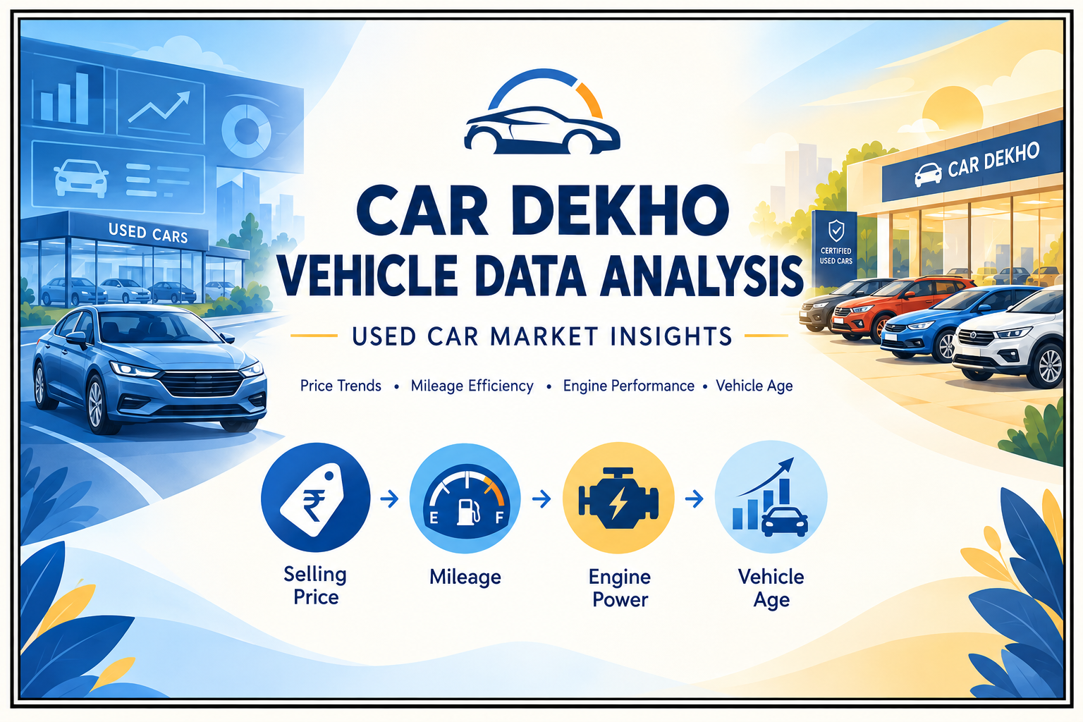

BY
GREESHMA R KRISHNAN

INTRODUCTION
The used car market plays an important role in the automobile industry, where factors such as brand, model, manufacturing year, mileage, engine capacity, transmission type, fuel type, and ownership history influence vehicle pricing and customer preferences. Analyzing these factors helps identify pricing patterns, compare vehicle performance, understand market trends, and evaluate the factors that affect the resale value of used cars. This project analyzes the Car Dekho dataset to explore vehicle specifications, selling prices, mileage efficiency, engine performance, and other attributes that influence the used car market.
The dataset was cleaned and prepared using Python to improve data quality and consistency, followed by Exploratory Data Analysis (EDA) to identify meaningful patterns and relationships among vehicle attributes. The prepared data was then used to develop an interactive Power BI dashboard featuring key performance indicators, price comparisons, brand and model analysis, and insights into vehicle characteristics and market trends.
Project Flow: Raw Data → Python Data Cleaning → EDA → Data Preparation → Power BI Dashboard → Business Insights

AIM
The primary aim of this project is to explore and derive meaningful insights from the Car Dekho used car dataset using Python, Exploratory Data Analysis (EDA), and Power BI. The analysis focuses on understanding vehicle pricing, specifications, mileage efficiency, and the factors influencing the resale value of used cars. Specifically, the analysis aims to:
- Analyze Vehicle Pricing: Examine selling prices across different brands, models, manufacturing years, and vehicle categories to identify pricing patterns.
- Evaluate Vehicle Characteristics: Analyze mileage, kilometers driven, engine capacity, maximum power, fuel type, transmission, and ownership history to understand their influence on vehicle valuation.
- Identify Relationships and Trends: Discover meaningful relationships between vehicle age, mileage efficiency, engine performance, and selling prices to understand used car market trends.
- Support Data-Driven Insights: Present key findings through an interactive Power BI dashboard to enable effective comparisons of vehicle attributes, pricing patterns, and market performance.
This analysis provides a practical approach to understanding the used car market while demonstrating the application of Python, EDA, and Power BI for real-world data analysis, visualization, and business insight generation.

OBJECTIVES
- Data Collection:
The Car Dekho dataset consists of 6,928 records and 18 attributes covering vehicle details, pricing, specifications, and usage characteristics. Key variables include vehicle name, manufacturing year, selling price, kilometers driven, fuel type, transmission, ownership history, mileage, engine capacity, maximum power, torque, and seating capacity. The dataset also includes derived attributes such as vehicle age, mileage efficiency level, engine category, and performance ratios, providing a foundation for analyzing used car pricing and vehicle characteristics.
- Data Cleaning and Preprocessing:
The raw dataset was cleaned and preprocessed using Python to improve data accuracy and consistency. The process included inspecting the dataset structure and data types, identifying missing and duplicate records, checking inconsistent or invalid values, standardizing categorical variables, validating numerical fields, and ensuring consistency in vehicle specifications. Additional calculated features, including vehicle age, mileage efficiency level, engine category, and performance ratios, were reviewed to support further analysis.
- Exploratory Data Analysis (EDA):
EDA was performed using Python to identify important patterns, distributions, and relationships within the dataset. The analysis examined selling prices, vehicle age, kilometers driven, mileage, engine capacity, maximum power, fuel type, transmission, and ownership history. Comparative and grouped analysis was conducted to understand pricing variations across vehicle brands, fuel types, transmission categories, ownership types, and vehicle age groups. The analysis also explored relationships between selling price, mileage efficiency, engine performance, and vehicle usage.
- Data Visualization and Dashboard Development:
The cleaned dataset was analyzed in Power BI to develop an interactive dashboard. KPIs, charts, and slicers were used to highlight key insights into vehicle pricing, mileage efficiency, engine performance, and used car market trends. The dashboard enables users to compare vehicle characteristics, explore price variations across different categories, and identify patterns that influence used car valuation.

DATA OVERVIEW

Column Name | Data Type
name | object
year | int64
selling_price | int64
km_driven | int64
fuel | object
seller_type | object
transmission | object
owner | object
mileage | float64
engine | Int64
Max_power | float64
torque | float64
seats | float64
Mileage_Efficient_Level | object
Engine_Category | object
Engine_Mileage_Ratio | float64
Power_Per_cc | float64
vehicle_age | int64

DATA ANALYSIS

1. Descriptive Analysis
This section provides an overview of the key characteristics of the Car Dekho dataset by examining average selling price, vehicle age, kilometers driven, mileage, engine capacity, and maximum power. It also analyzes fuel types, transmission systems, ownership history, and vehicle specifications to understand the overall characteristics of the used car market.

2. Relationship & Trend Analysis
This section examines the relationships between vehicle characteristics and selling prices. The analysis focuses on how manufacturing year, vehicle age, kilometers driven, mileage, engine capacity, and maximum power are associated with vehicle valuation and pricing patterns. These comparisons help identify important trends and factors related to used car prices.

3. Vehicle & Category Analysis
This section analyzes differences in vehicle pricing and specifications across car brands, models, fuel types, transmission types, and ownership categories. It also examines mileage efficiency levels, engine categories, and vehicle age groups to understand how vehicle characteristics vary and contribute to differences in the used car market.

4. Pricing & Performance Analysis
This section focuses on identifying factors associated with used car pricing and vehicle performance. Selling prices are compared across different vehicle age groups, mileage efficiency levels, engine capacities, power categories, and ownership histories. The analysis helps highlight patterns between vehicle characteristics, specifications, usage, and resale value.

QUESTIONS
- Which car brands/models are most common in the dataset?
print(df["Name"].value_counts().head(10))

- Does vehicle age affect selling price?
df['vehicle_age'] = 2026 - df['year']
print(df[['vehicle_age', 'selling_price']].corr())

sns.scatterplot(data=df, x='vehicle_age', y='selling_price',color="Brown")
plt.title('Vehicle Age vs Selling Price')
plt.xlabel('Vehicle Age')
plt.ylabel('Selling Price')
plt.show()

- Does kilometres driven affect selling price?
print(df[["km_driven","selling_price"]].corr())

sns.scatterplot(data=df, x="km_driven",y="selling_price",color="Brown")
plt.title("Kilometres Driven vs Selling Price")
plt.xlabel('Kilometres Driven')
plt.ylabel('Selling Price')
plt.show()

- Does seller type have a relationship with selling price?
seller_price = df.groupby('seller_type')['selling_price'].agg(
['count', 'mean', 'median', 'min', 'max']
)

print(seller_price)

- Which fuel type has the highest number of used-car listings?
fuel_count = df['fuel'].value_counts()
print(fuel_count)
print("\nMost common fuel type:", fuel_count.idxmax())

fuel_count = df['fuel'].value_counts().plot(kind='bar',color="Brown")

- Which transmission type has the highest average selling price?
transmission_analysis = df.groupby('transmission')['selling_price'].agg(
['count', 'mean', 'median']
).sort_values('mean', ascending=False)

print(transmission_analysis)

- What is the average selling price for each seller type?
df.groupby("seller_type")["selling_price"].mean()

- Which seller type provides the highest-priced vehicles?
seller_analysis = df.groupby('seller_type')['selling_price'].agg(
['count', 'mean', 'median', 'min', 'max'])

highest_seller = seller_analysis['mean'].idxmax()
print("Seller type with highest average price:",
highest_seller)
print("Average price:", seller_analysis.loc
[highest_seller,'mean'])
- How does ownership history affect the resale value of cars?
owner_analysis = df.groupby('owner')['selling_price'].agg(
['count', 'mean', 'median']
).sort_values('mean', ascending=False)

print(owner_analysis)

- Which combination of car attributes is associated with the highest selling price?
combination_analysis = (
df.groupby(['fuel', 'transmission'])['selling_price']
.agg(['count', 'mean', 'median'])
.sort_values('mean', ascending=False)
)

print(combination_analysis)

- What is the average mileage for each fuel type in the Car Dekho dataset?
df.groupby("fuel")["mileage"].mean()

- Which vehicles have high prices despite high kilometres driven?
high_price = df['selling_price'].quantile(0.75)
high_km = df['km_driven'].quantile(0.75)

result = df[
(df['selling_price'] >= high_price) &
(df['km_driven'] >= high_km)]

print(result[['Name', 'year', 'km_driven', 'selling_price']])

- How does the distance driven by cars vary across different manufacturing years?
plt.figure(figsize=(16,6))
sns.barplot(x='year', y='km_driven', data=df)
plt.title('Km_driven by Year')
plt.show()

- How does vehicle age affect the selling price of used cars?
plt.figure(figsize=(12, 6))
sns.barplot(x='year', y='selling_price', data=df, errorbar=None)

plt.title('Average Selling Price by Manufacturing Year')
plt.xlabel('Manufacturing Year')
plt.ylabel('Average Selling Price')
plt.xticks(rotation=45)
plt.tight_layout()
plt.show()

CONCLUSION:
The analysis of the Car Dekho used car dataset provides valuable insights into vehicle pricing, specifications, and factors associated with resale value. The project examines important attributes such as selling price, manufacturing year, kilometers driven, fuel type, transmission, seller type, ownership history, mileage, engine capacity, and maximum power. Using Python and Pandas, the data was analyzed through statistical summaries, group comparisons, filtering, and correlation analysis. These analyses help identify common vehicle listings, compare average selling prices across seller and transmission types, understand pricing variations by ownership history, and explore the relationships between vehicle age, kilometers driven, mileage, and selling price.
Overall, the project demonstrates how data analysis can transform raw vehicle data into meaningful insights about the used car market. The analysis of fuel types, transmission categories, seller types, ownership history, and vehicle specifications provides a broader understanding of pricing patterns and vehicle characteristics. Identifying high-priced vehicles with high kilometers driven also helps explore cases where resale prices remain relatively high despite extensive usage. These findings can support better vehicle comparisons and informed pricing decisions while recognizing that the observed relationships represent associations within the dataset rather than direct cause-and-effect relationships.

- Which car brands/models are most common in the dataset?
The value_counts() function was used to identify the most frequently listed car names in the dataset. The top 10 vehicles were selected to understand which brands and models appear most often. This analysis helps identify the most commonly available vehicles in the used car market.

Maruti Swift Dzire VDI | 118
Maruti Alto 800 LXI | 76
Maruti Alto LXi | 69
Maruti Swift VDI | 60
Maruti Swift VDI BSIV | 56
Maruti Alto K10 VXI | 47
Hyundai EON Era Plus | 44
Maruti Alto LX | 43
Maruti Wagon R VXI BS IV | 43
Maruti Ertiga VDI | 42

- Does vehicle age affect selling price?
The vehicle age was calculated by subtracting the manufacturing year from 2026. Correlation analysis and a scatter plot were used to examine the relationship between vehicle age and selling price. This analysis helps understand how vehicle age is associated with resale value and whether older vehicles tend to have different pricing patterns.

 | vehicle_age | selling_price
vehicle_age | 1.000000 | -0.435419
selling_price | -0.435419 | 1.000000

- Does kilometres driven affect selling price?
Correlation analysis and a scatter plot were used to examine the relationship between kilometers driven and selling price. This analysis helps identify whether vehicle usage is associated with changes in resale value and whether cars with higher kilometers driven tend to have different selling prices.

 | km_driven | selling_price
km_driven | 1.000000 | -0.169122
selling_price | -0.169122 | 1.000000

- Does seller type have a relationship with selling price?
The dataset was grouped by seller type, and count, mean, median, minimum, and maximum selling prices were calculated. This analysis helps compare pricing patterns among individual sellers, dealers, and other seller categories represented in the dataset. It also provides an overview of price variations across seller types.

seller_type | count | mean | median | min | max
Dealer | 683 | 933783.257687 | 620000.0 | 60000 | 6523000
Individual | 6218 | 473251.488260 | 390000.0 | 29999 | 10000000
Trustmark Dealer | 27 | 718111.111111 | 650000.0 | 225000 | 2000000

- Which fuel type has the highest number of used-car listings?
The value_counts() function was used to calculate the number of listings for each fuel type. The idxmax() function identified the fuel category with the highest number of vehicles. This analysis helps understand the distribution of fuel types and identify the most commonly listed fuel category in the dataset.

Fuel
Diesel | 3752
Petrol | 3081
CNG | 56
LPG | 38
Electric | 1

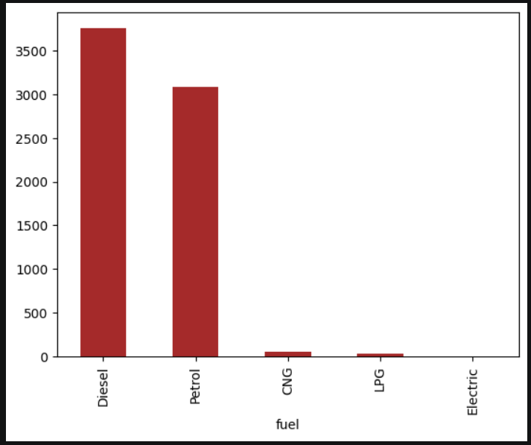

- Which transmission type has the highest average selling price?
The dataset was grouped by transmission type, and the count, mean, and median selling prices were calculated. The results were sorted in descending order based on average selling price. This analysis helps compare manual and automatic vehicles and identify which transmission category has the highest average selling price.

Transmission | Count | Mean | Median
Automatic | 586 | 1.323311e+06 | 850000.0
Manual | 6342 | 4.453454e+05 | 390000.0

- What is the average selling price for each seller type?
The groupby() function was used to group vehicles according to seller type, and the average selling price was calculated for each group. This analysis provides a simple comparison of average vehicle prices across seller categories and helps identify differences in their pricing patterns.

Seller_Type
Dealer | 937224.112082
Individual | 472912.829589
Trustmark Dealer | 718111.111111

- Which seller type provides the highest-priced vehicles?
The dataset was grouped by seller type to calculate the count, mean, median, minimum, and maximum selling prices. The seller category with the highest average selling price was identified using idxmax(). This analysis helps determine which seller type has the highest average vehicle price. The result reflects average prices rather than necessarily identifying the category with the single most expensive vehicle.

Seller type with highest average price: Dealer
Average price: 933783.2576866765

- How does ownership history affect the resale value of cars?
The dataset was grouped by ownership category, and the count, mean, and median selling prices were calculated. The results were sorted according to average selling price to compare vehicles with different ownership histories. This analysis helps explore how the number or type of previous owners is associated with vehicle resale value.

Owner | Count | Mean | Median
Test Drive Car | 5 | 4.403800e+06 | 5923000.0
First Owner | 4249 | 6.183778e+05 | 500000.0
Second Owner | 1972 | 3.872126e+05 | 310000.0
Third Owner | 534 | 2.789616e+05 | 222500.0
Fourth & Above Owner | 168 | 2.249136e+05 | 175000.0

- Which combination of car attributes is associated with the highest selling price?
The dataset was grouped by fuel type and transmission type, and the count, mean, and median selling prices were calculated for each combination. The results were sorted by average selling price in descending order. This analysis helps identify fuel and transmission combinations associated with higher average vehicle prices. The number of vehicles in each group should also be considered when interpreting the results.

Fuel | Transmission | count | Mean | Median
Electric | Automatic | 1 | 2.650000e+06 | 2650000.0
Diesel | Automatic | 298 | 1.800104e+06 | 1350000.0
Petrol | Automatic | 287 | 8.236202e+05 | 600000.0
Diesel | Manual | 3454 | 5.412883e+05 | 495000.0
Petrol | Manual | 2794 | 3.329731e+05 | 300000.0
CNG | Manual | 56 | 3.004999e+05 | 320000.0
LPG | Manual | 38 | 2.004211e+05 | 195500.0

- What is the average mileage for each fuel type in the Car Dekho dataset?
The dataset was grouped by fuel type, and the average mileage was calculated for each category using the groupby() and mean() functions. This analysis helps compare the reported fuel efficiency of vehicles using different fuel types and identify variations in average mileage across categories.

Fuel
CNG | 23.632143
Diesel | 19.726919
Electric | 32.500000
LPG | 18.626316
Petrol | 19.110354

- Which vehicles have high prices despite high kilometres driven?
The 75th percentile was calculated for both selling price and kilometers driven. Vehicles with selling prices and kilometers driven at or above their respective 75th-percentile values were filtered from the dataset. This analysis identifies vehicles that have relatively high selling prices despite extensive usage and helps explore exceptions to general resale pricing patterns.

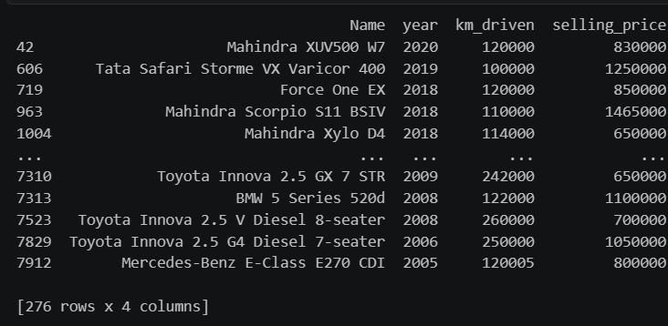

- How does the distance driven by cars vary across different manufacturing years?
This bar chart compares the manufacturing year of cars with the distance they have been driven (km_driven). It helps identify how driving distance varies among cars from different years and whether older or newer vehicles tend to have higher recorded mileage. This analysis can help understand vehicle usage patterns in the used-car market.
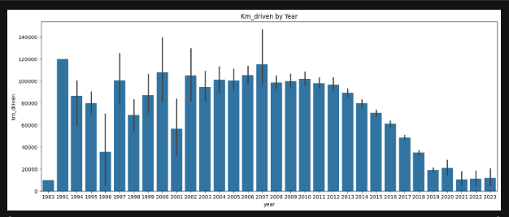
- How does vehicle age affect the selling price of used cars?
This bar chart compares the average selling price of used cars across different manufacturing years. It helps identify how vehicle age relates to resale value and whether newer cars generally have higher average selling prices than older cars. This analysis supports understanding depreciation patterns in the used-car market.



